

The Latymer School

Sixth Form Open Evening for New Applicants

Tuesday 1st November 2022
5.00pm – 7.00pm

This programme contains the following information:

Page 2 General information about the evening
Page 3 A Level results for 2021 and 2022
Pages 4/5 Map of the school
Pages 6/7 Timetable for the evening
Page 8 Options Timeline
Page 9 External Applicants entry reminder

  - All information can be found on our website
  - www.latymer.co.uk

General Information

Subject specialists are giving details of the courses offered in the Sixth Form in the venues indicated inside this programme. Some subjects will deliver specific scheduled presentations, whereas others will provide opportunities for discussing the subject with relevant staff.

  - Mrs Cobbett (Headteacher), Mr Wakefield (Deputy Head – Sixth Form), Mr Grassick (Deputy Head – Curriculum) and Sixth Form Heads of Learning will be available in the Small Hall throughout the evening to answer any individual questions

A Level RESULTS ACHIEVED BY YEAR GROUP 13

2022: Number of students in Year 13: 209
A Level Subject | Entries | A* | A | B | C | D | E | U | X
Art A2 | 13 | 5 | 5 | 2 | 1 | 0 | 0 | 0 | 0
Biology A2 | 84 | 31 | 28 | 15 | 7 | 1 | 1 | 0 | 1
Chemistry A2 | 97 | 22 | 38 | 17 | 11 | 7 | 1 | 0 | 1
Economics A2 | 45 | 7 | 16 | 17 | 5 | 0 | 0 | 0 | 0
English Literature A2 | 30 | 12 | 8 | 8 | 2 | 0 | 0 | 0 | 0
French A2 | 21 | 8 | 9 | 4 | 0 | 0 | 0 | 0 | 0
Further Mathematics A2 | 48 | 21 | 6 | 4 | 15 | 1 | 0 | 1 | 0
Geography A2 | 27 | 15 | 8 | 4 | 0 | 0 | 0 | 0 | 0
German A2 | 8 | 3 | 5 | 0 | 0 | 0 | 0 | 0 | 0
History A2 | 25 | 9 | 9 | 5 | 1 | 0 | 0 | 0 | 1
Mathematics A2 | 149 | 53 | 61 | 13 | 9 | 11 | 1 | 0 | 1
Media Studies A2 | 3 | 2 | 1 | 0 | 0 | 0 | 0 | 0 | 0
Music A2 | 10 | 4 | 2 | 2 | 2 | 0 | 0 | 0 | 0
Physics A2 | 71 | 29 | 26 | 7 | 5 | 3 | 1 | 0 | 0
Politics A2 | 17 | 6 | 6 | 3 | 2 | 0 | 0 | 0 | 0
Religious Studies A2 | 18 | 6 | 3 | 4 | 2 | 2 | 1 | 0 | 0
Russian A2 | 9 | 5 | 4 | 0 | 0 | 0 | 0 | 0 | 0
Total | 675 | 238 | 235 | 105 | 62 | 25 | 5 | 1 | 4

2021: Number of students in Year 13: 214
A Level Subject | Entries | A* | A | B | C | D | E | U | X
Art A2 | 16 | 7 | 5 | 4 | 0 | 0 | 0 | 0 | 0
Biology A2 | 92 | 35 | 40 | 12 | 2 | 2 | 1 | 0 | 0
Chemistry A2 | 95 | 17 | 44 | 18 | 13 | 2 | 1 | 0 | 0
Economics A2 | 41 | 14 | 19 | 8 | 0 | 0 | 0 | 0 | 0
English Literature A2 | 28 | 11 | 12 | 4 | 1 | 0 | 0 | 0 | 0
French A2 | 15 | 5 | 8 | 2 | 0 | 0 | 0 | 0 | 0
Further Maths A2 | 39 | 21 | 11 | 4 | 1 | 1 | 1 | 0 | 0
Geography A2 | 30 | 13 | 12 | 4 | 1 | 0 | 0 | 0 | 0
German A2 | 7 | 3 | 4 | 0 | 0 | 0 | 0 | 0 | 0
History A2 | 28 | 9 | 14 | 3 | 1 | 1 | 0 | 0 | 0
Mathematics A2 | 161 | 73 | 54 | 26 | 4 | 1 | 2 | 1 | 0
Media A2 | 4 | 2 | 2 | 0 | 0 | 0 | 0 | 0 | 0
Music A2 | 12 | 8 | 4 | 0 | 0 | 0 | 0 | 0 | 0
Physics A2 | 65 | 20 | 23 | 11 | 9 | 2 | 0 | 0 | 0
Politics A2 | 14 | 4 | 5 | 4 | 0 | 1 | 0 | 0 | 0
Religious Studies A2 | 11 | 4 | 5 | 1 | 1 | 0 | 0 | 0 | 0
Russian A2 | 14 | 9 | 5 | 0 | 0 | 0 | 0 | 0 | 0
Theatre A2 | 3 | 3 | 0 | 0 | 0 | 0 | 0 | 0 | 0
Total | 676 | 259 | 267 | 101 | 33 | 10 | 5 | 1 | 0
Please note: U and X columns comprise unclassified and absent

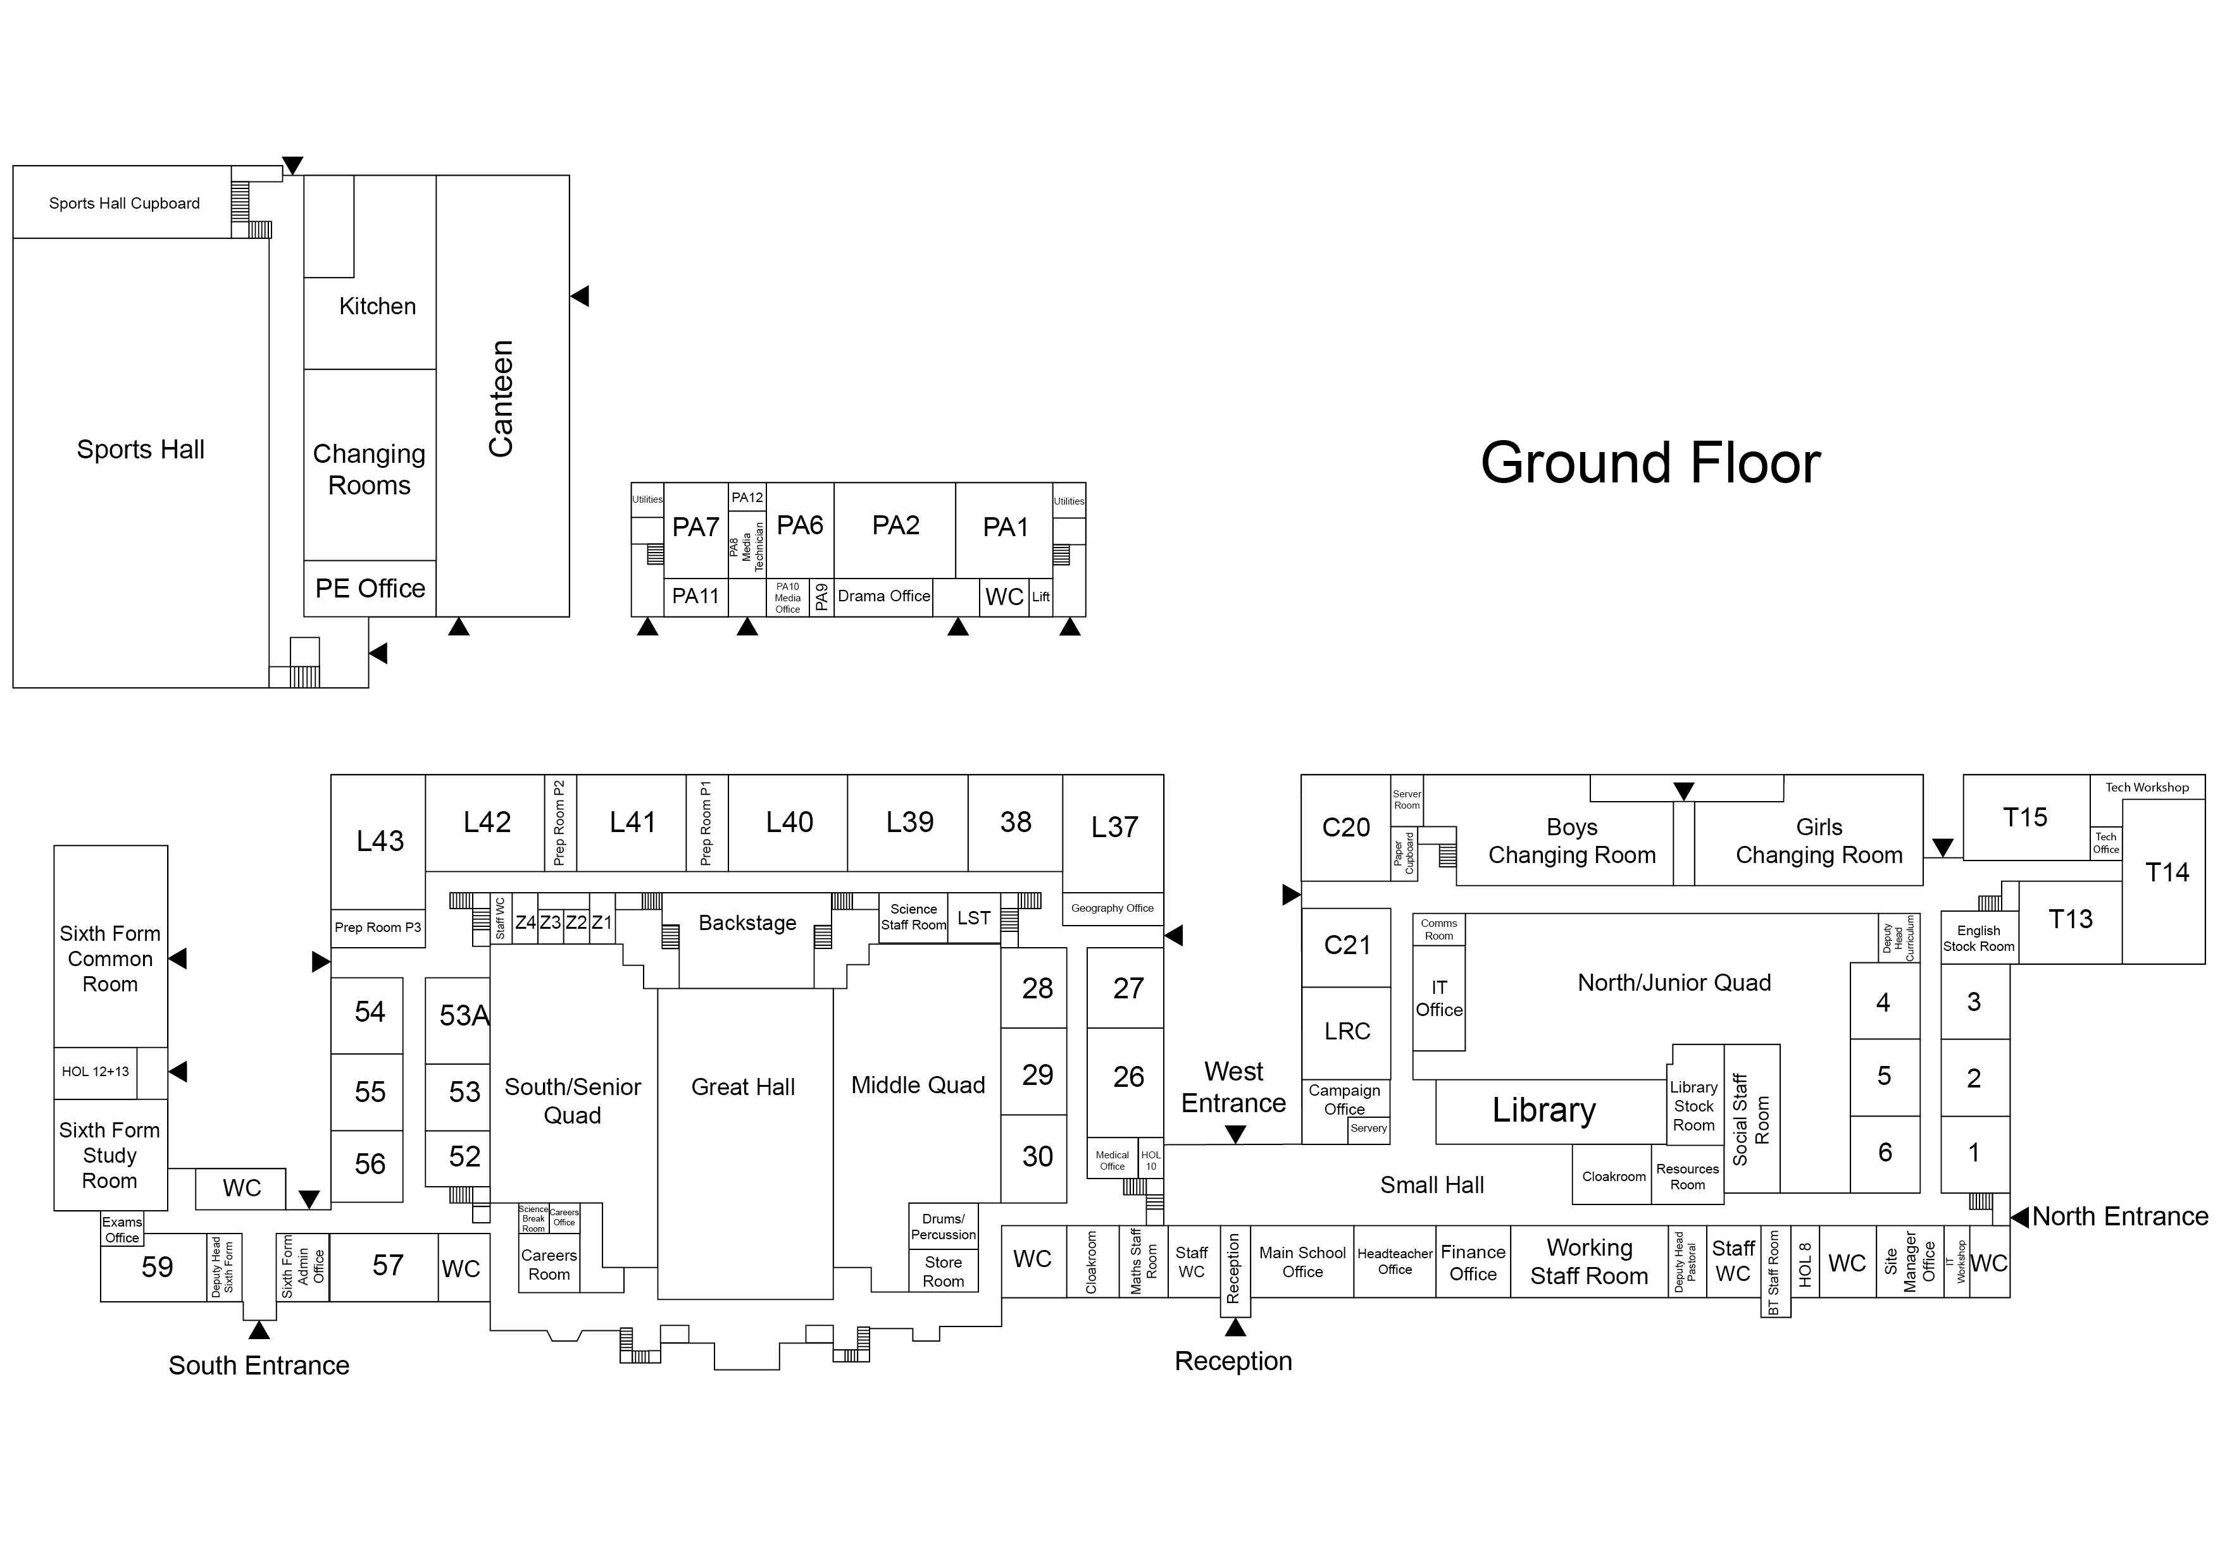

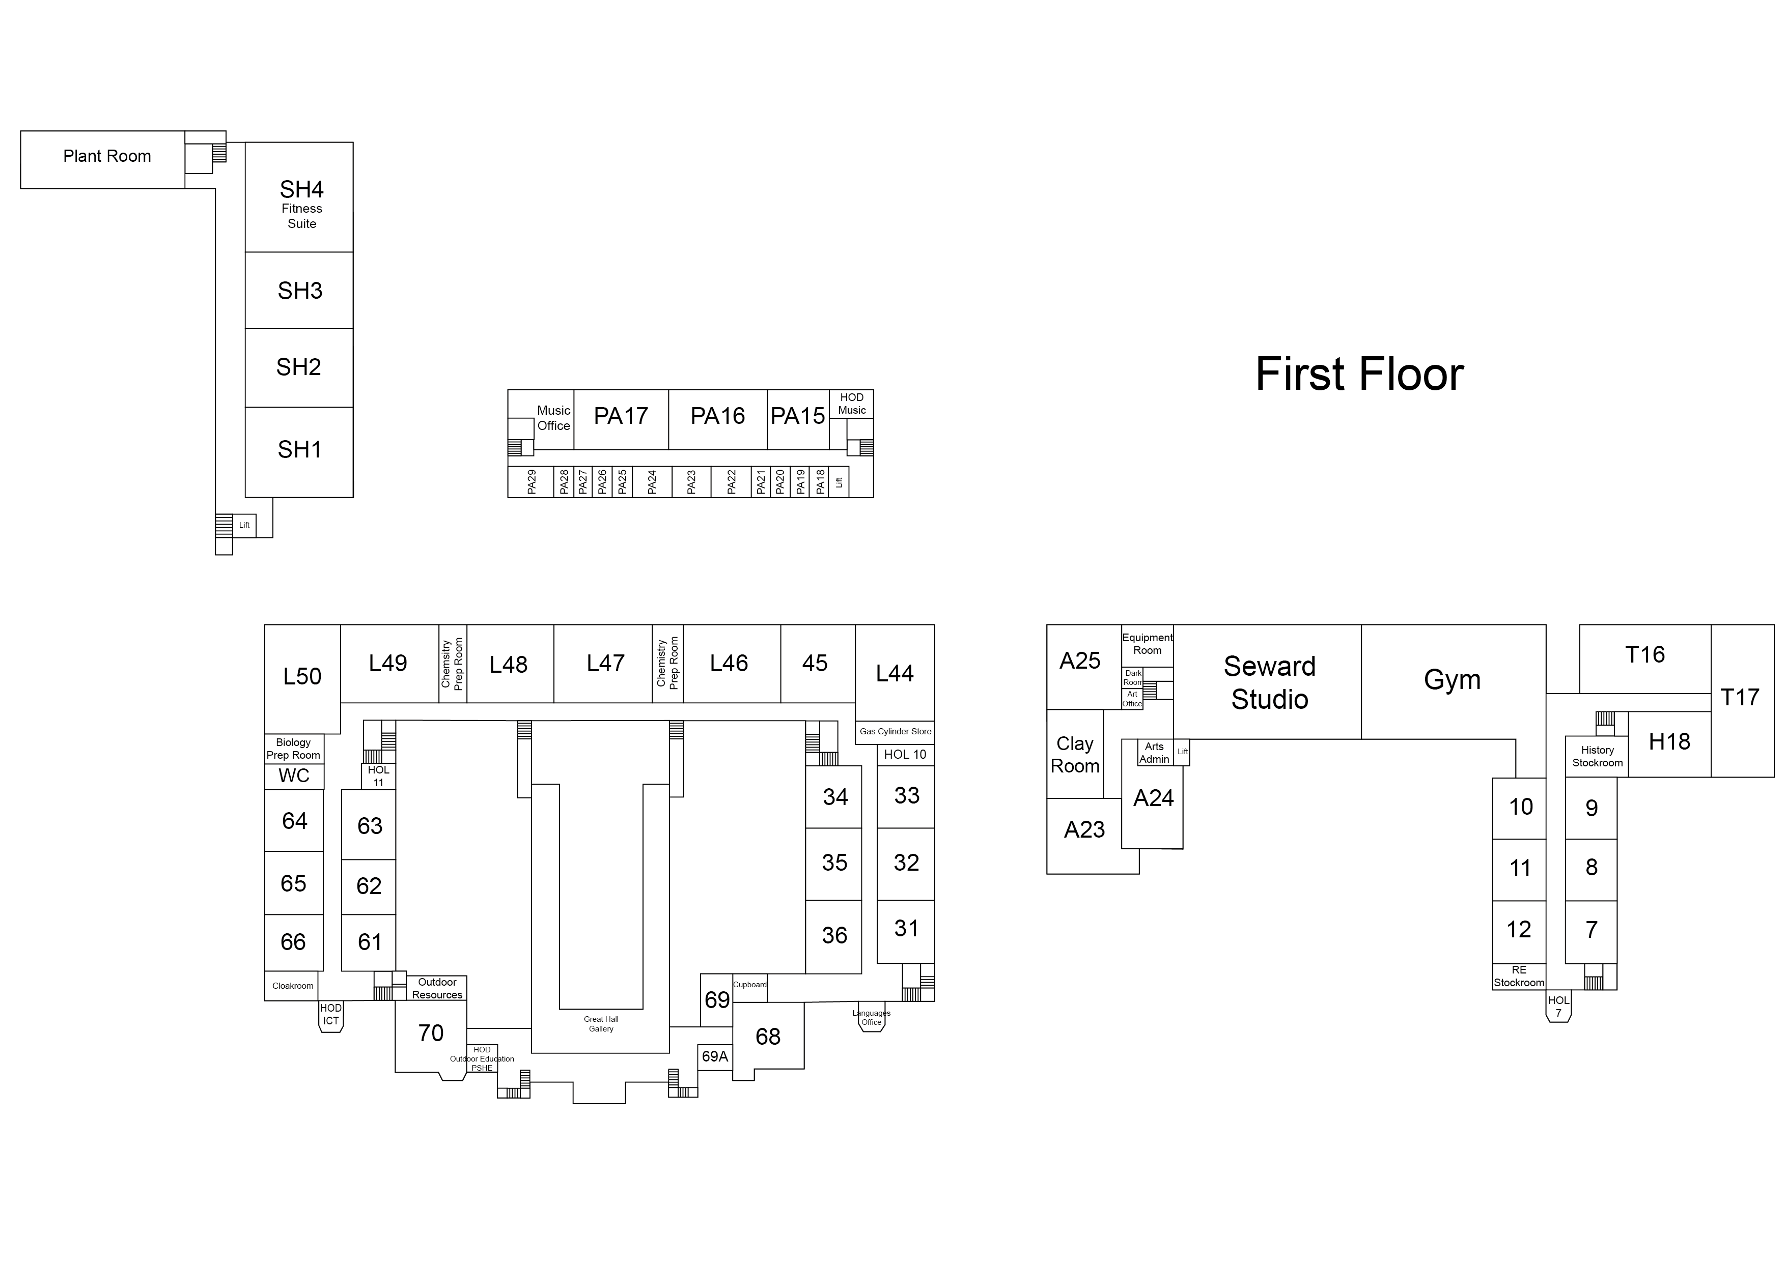

Timetable
 | Venue | Times
General  Information  Session | Great Hall | 6.00p.m.
Maths / Economics presentations | Great Hall | Maths 5.05 p.m.  Economics 5.30 p.m.  Maths 6.25 p.m.
Science presentations | Seward Studio | Biology 5.05 p.m.  Chemistry 5.25 p.m.  Physics 6.45 p.m.
Individual questions  throughout the evening to Senior Staff | Small Hall | 5.00 p.m. – 7.00 p.m.
Subject presentations and consultations | See Timetable ‘Subject Locations & Presentations’ | Each subject will deliver a presentation or discussion in the room shown on the subject timetable  5.00 p.m. to 7.00 p.m.

To avoid disruption please do not walk in and out of
timetabled presentations - the evening is a very busy one, so please be
considerate, and patient, as you move around the school

Refreshments will be available in the
Small Hall throughout the evening, where there will be live music played, and 6th Form students will answer questions

Subject locations and presentations

Timetabled Presentations (P) and Consultations (C)

In these sessions the subject specialist will give details of:
- the syllabus taught, its demands and controlled assessment
- the teaching methodology
- pre-requirements of a course
- student perceptions of the course
There will also be an opportunity to ask Latymer staff and student questions about courses

TIME  Presentation (P)  Consultation (C) | 5.05pm-5.20pm | 5.25pm– 5.45pm | 6.20pm– 6.35pm | 6.40pm– 6.55pm
Art | C - A23  C – A24 | C - A23  C – A24 | C - A23  C – A24 | C - A23  C – A24
Biology | P – Seward Studio | C- L41, L42, L43 | P - L42  C- L41, L43 | P - L42  C- L41, L43
Chemistry | C - L46, L47, L48 | P – Seward Studio | P – L46  C – L47, L48 | P – L46  C – L47, L48
Economics | P - Rm 52  C – Rm 56 | P – Great H.  C – Rm 56 | P - Rm 52  C – Rm 56 | P - Rm 52  C – Rm 56
English | P - Library | P - Library | P - Library | P - Library
French | C - Rm 68 | C - Rm 68 | C - Rm 68 | C - Rm 68
German | C - Rm 28 | C - Rm 28 | C - Rm 28 | C - Rm 28
Russian | C - Rm 31 | C - Rm 31 | C - Rm 31 | C - Rm 31
Geography | P – Rm 45  C – Rm 27 | P – Rm 45  C – Rm 27 | P – Rm 45  C – Rm 27 | P – Rm 45  C – Rm 27
Government & Politics | P – Rm 10 | P – Rm 10 | P – Rm 10 | P – Rm 10
History | P – Rm 9 | P – Rm 9 | P – Rm 9 | P – Rm 9
Maths / Further Maths | P– Great Hall  C – Rm 57 | C – Rm 57, 62, 66 | C– Rm 57, 62, 66 | P – Great Hall (6.25p.m)  C – Rm 57, 62, 66
Media | P - PA6 | P - PA6 | P - PA6 | P - PA6
Music | P/C - PA17 | P/C - PA17 | P/C - PA17 | P/C - PA17
Physics | P - L 41  C – L40, L42 | P - L 41  C – L40, L42 | C - L 40, L41, L42 | P – Seward Studio
Religious Studies:  Philosophy & Ethics | C - Rm 11 | C - Rm 11 | C - Rm 11 | C - Rm 11
Design Technology | C – T13 | C – T13 | C – T13 | C – T13

Timeline for the Application Process

New applicants
Wednesday 30th November 2022 4pm:
Closing date for applications – only online applications accepted

By the 16th December 2022:
You should have received notification of test time

Saturday 7th January 2023:
Sixth Form entrance tests

End of March 2023:
Conditional offers made
Thursday 24th August 2023
(GSCE results day) :
Email your results to the school by Friday 25th August, 12 pm to confirm you have met the requirements to take up your place by 12.00p.m.

Reminder to new applicants

Latymer is a selective grammar school. Applicants for Year 12 are tested and the school admits those with the highest scores who meet the minimum GCSE requirements. The minimum GCSE requirements are: (1) at least numerical grade 7 in the subjects they wish to study in the Sixth Form; and (2) at least 6 numerical grade 7's overall at GCSE.

Tests are administered in the Spring Term for applicants wishing to study any of Mathematics, Biology, Chemistry or Physics. Provisional offers are made to applicants with the highest score in the test (except that subject choices may mean that some subjects become full and further places cannot be offered to applicants seeking to study those subjects). If you do not sit the test you will not be allowed to study these subjects at Latymer and therefore if an applicant is considering them as possible options they should sit the test. The offer is provisional and becomes a full offer only if the applicant’s GCSE grades meet the minimum GCSE requirements. (6 numerical grade 7’s in full GCSEs and numerical grade 7 in each subject to be studied, where applicable) Applicants who are new to the school must have their main address in the Inner Area. (see Notes section in our current admissions procedures document).

Any applicant wishing to study subjects that do not include any of the subjects above does not have to sit the test to get a conditional offer. If there is capacity in the subjects requested the decision to make a conditional offer will be based on mock exam results and predicted grades from an applicant’s current school. An applicant will not be allowed to switch to the subjects requiring the test if they haven’t sat the test on the date advertised for entry in that year. There will not be an opportunity to sit the test at a later date. The offer is provisional and becomes a full offer only if the applicant’s GCSE grades meet the minimum GCSE requirements outlined above.

Application Forms are available from the school website under: www.latymer.co.uk/north-london-grammar-school-admissions/sixth-form/2023

These should be completed and submitted online by 4pm on Wednesday 30th November 2022.

